c

**Tech & Telecom (20)**

AAPL, ADBE, AMD, AMZN, ASML, AVGO, CMCSA, CRM, CSCO, GOOGL, INTC, MSFT, NFLX, NVDA, ORCL, QCOM, SAP, TMUS, TSM, TXN

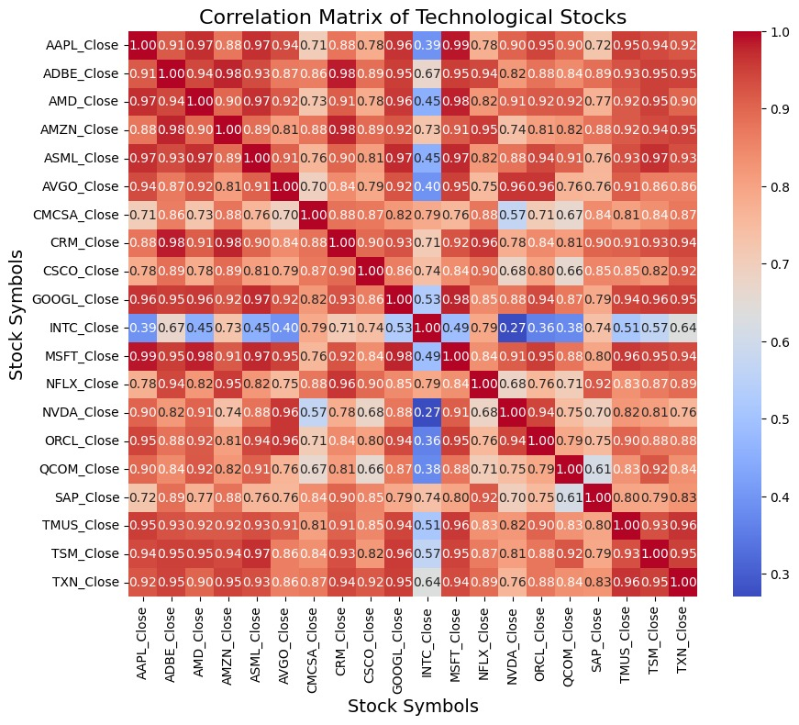

**Financial (20)**

ACN, AXP, BAC, BLK, BRK.B, BX, C, DB, GS, HSBC, IBKR, INTU, JPM, MA, MS, MUFG, SCHW, UBS, V, WFC

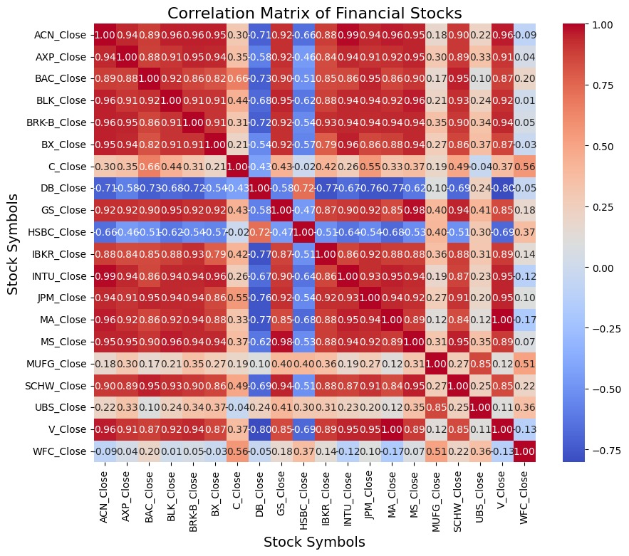

**Healthcare & Medical Insurance (15)**

AAGIY, ABT, AZN, CI, CNC, CVS, JNJ, LLY, MCK, MRK, NVO, NVS, PFE, TMO, UNH

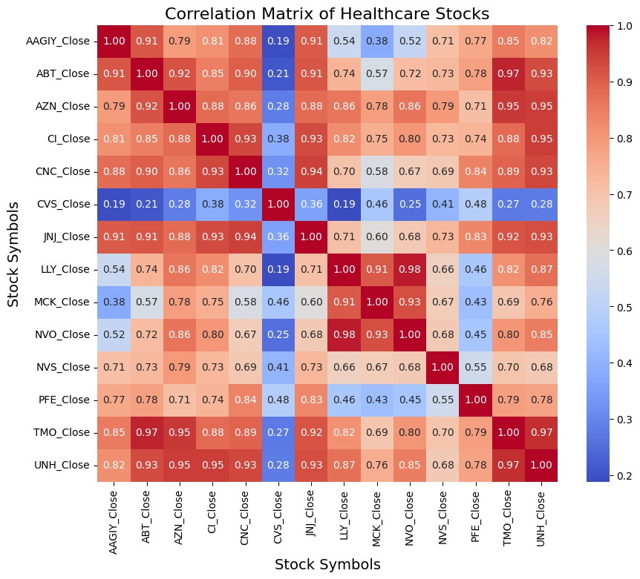

**F&B (14)**

BG, CMG, CPB, FMX, GIS, KO, MCD, MDLZ, MNST, NSRGF, PEP, TSN, STZ, YUM

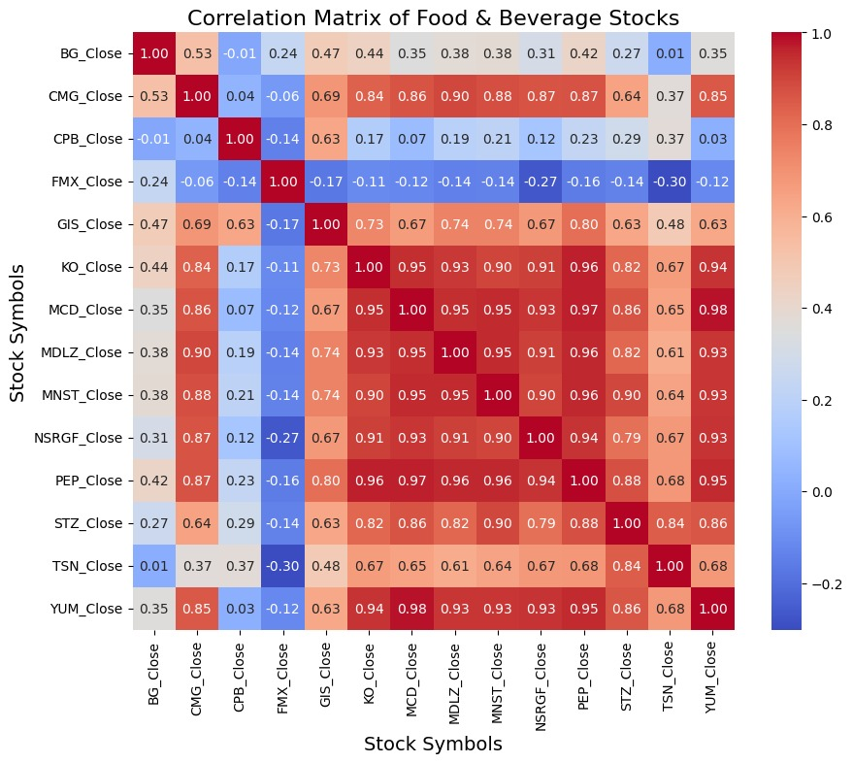

**Energy & Materials (13)**

ALB, ARLP, COP, CVX, EOG, LIN, PXD, MPC, OXY, SHEL, SLB, VLO, XOM

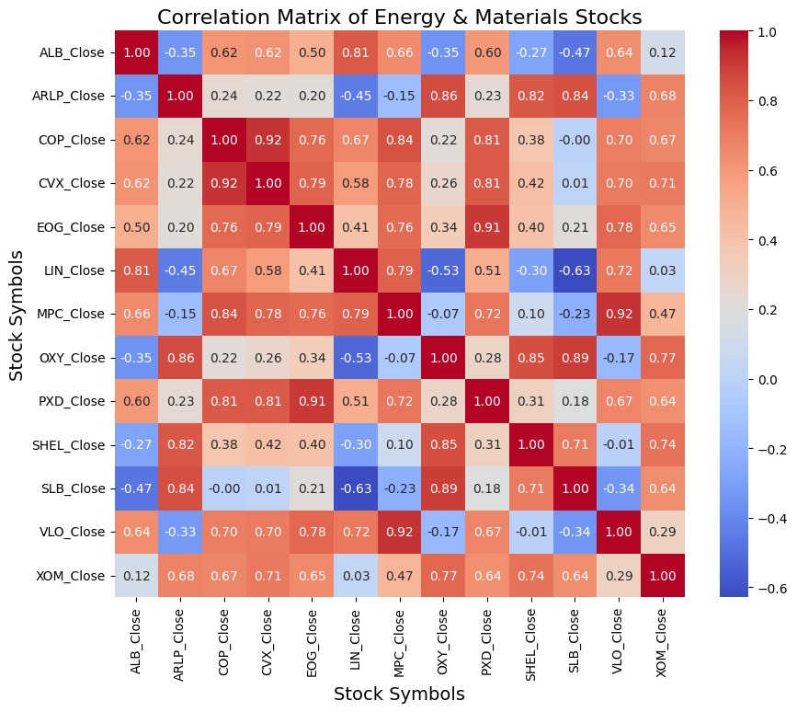

**10-year US interest rate**

**Monthly CPI / PCE**

**Quarterly GDP**